|  |  |  |  |  |
| --- | --- | --- | --- | --- |
| Get Youtube Likes Step by Step | | | | |
|  |  | | |  |
| Likes | | | | |
|  | | Step by Step |  | |

TABLE OF CONTENTS

Introduction 3

1. Before We Start 4

2. Authentication 7

3. Extract statistics 8

4. Sample JSON 9

# Introduction

This document is intended for developers who want to write applications that interact with YouTube. It explains basic concepts of getting the count of Likes on a YouTube Video using the Google API.

# Before We Start

* You need a Google Account to access the Google API Console, request an API key, and register your application.

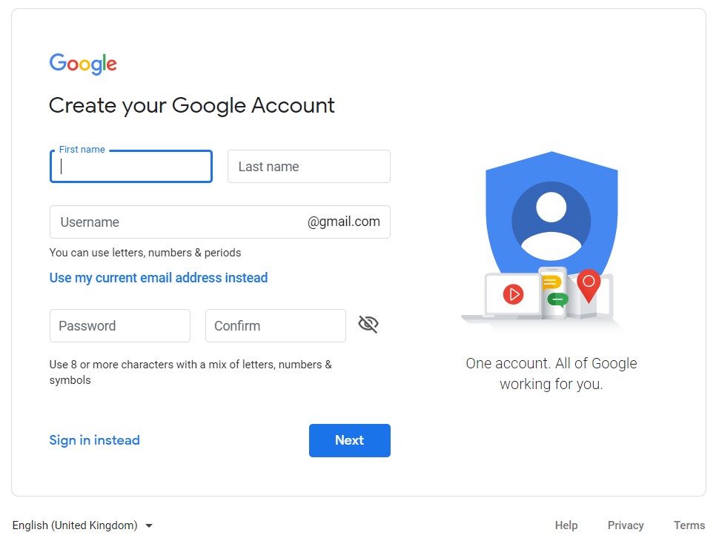

* Create a project in the Google Developers Console and obtain authorization credentials so your application can submit API requests.

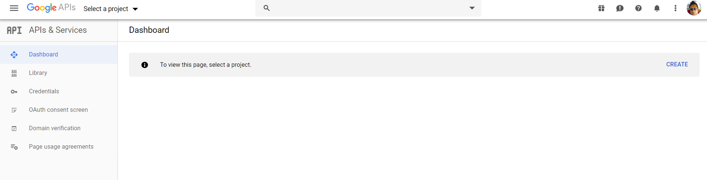

* After creating your project, make sure the YouTube Data API is one of the services that your application is registered to use:

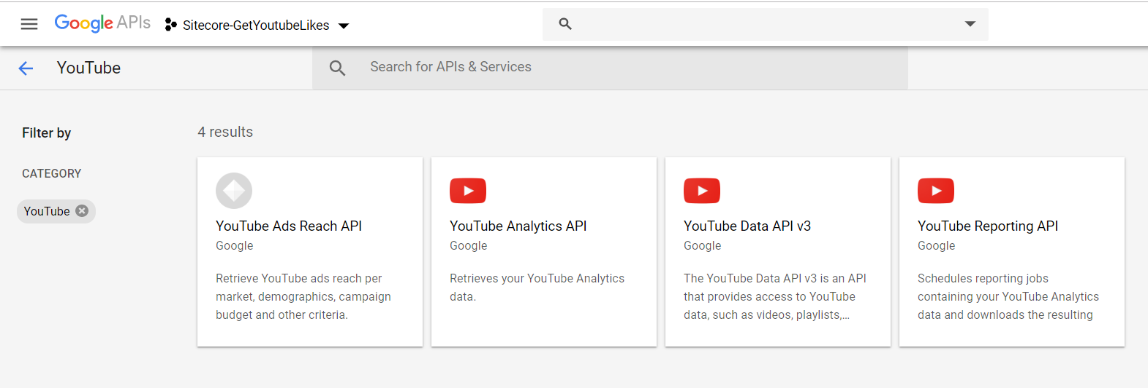

* Go to the API Console and select the project that you just registered.

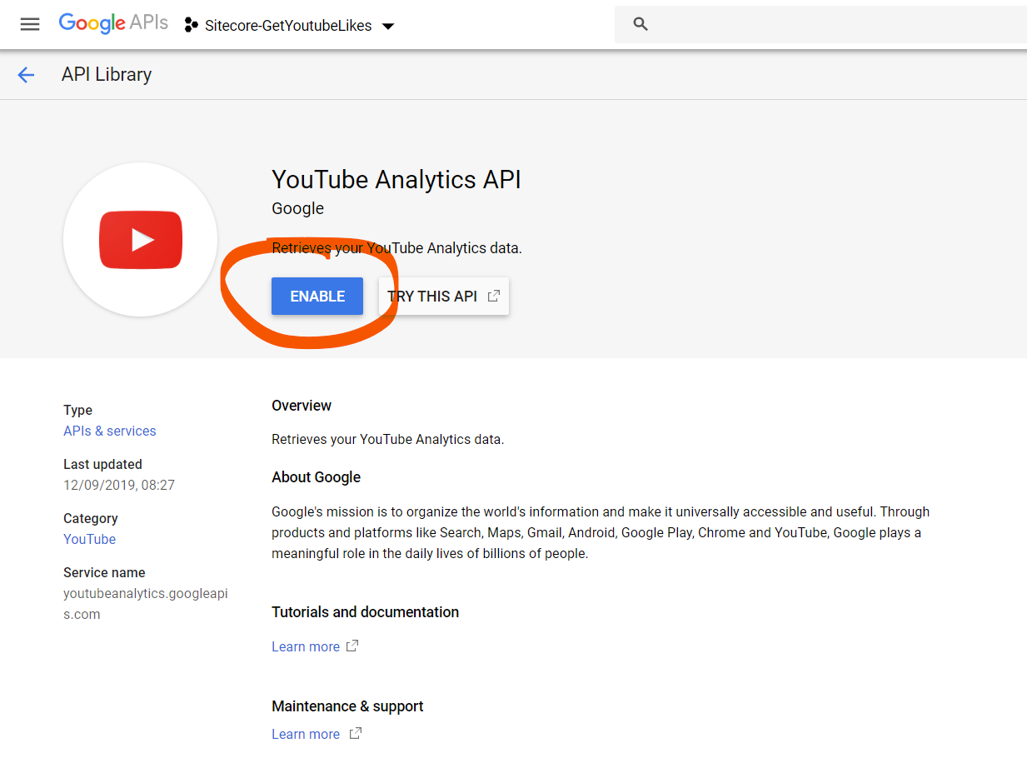

* Visit the Enabled APIs page. In the list of APIs, make sure the status is ON for the YouTube Data API v3.
* If your application will use any API methods that require user authorization, read the authentication guide to learn how to implement OAuth 2.0 authorization.
* Select a [client library](https://developers.google.com/api-client-library/dotnet/get_started) to simplify your API implementation.

# Authentication

The above information is given only for the information. However, the Authentication / Obtaining keys and permission has already been taken care by Sitecore. You can obtain the API Key from your administrator.

# Extract statistics

Now we will learn how to extract statistics on YouTube Videos using the YouTube API.

1. Sending the request on YouTube data API.

https://www.googleapis.com/youtube/v3/videos?id=zUMWyXTnLe4&key=YOUR_API_KEY&part=statistics

Now if we closely analyze the URL. We will find that there are 3 query parameters

id=zUMWyXTnLe4

key=YOUR_API_KEY

part=statistics

* + **ID:** This is the ID of video you are looking to pull information for. You can find video ID as part of the video URL.



* + **Key:** Just paste your API Key provided by your administrator.
  + **Part=Statistics**: This is where we ask YouTube API, kind of information we are going to fetch from a particular video. We set this to “**statistics**” because in this section we used to retrieve YouTube video views count, likes count, dislikes count, number of times the video has been added to favorites and comments count.

1. Parse API response: After we send a request to the URL mentioned with our valid API key, we should receive a JSON response. For testing purposes, we can test if our request is working by pasting that URL directly in browser.

# Sample JSON

The Sample JSON Response of query will be something like this

{

"kind": "youtube#videoListResponse",

"etag": "\"p4VTdlkQv3HQeTEaXgvLePAydmU/ccHKgLQB84trU6bOUlEUcQ8ggbI\"",

"pageInfo": {

"totalResults": 1,

"resultsPerPage": 1

},

"items": [

{

"kind": "youtube#video",

"etag": "\"p4VTdlkQv3HQeTEaXgvLePAydmU/4IDe7WRDhkcuzZRntlGYfc8WieM\"",

"id": "zUMWyXTnLe4",

"statistics": {

"viewCount": "6944040",

"likeCount": "15726",

"dislikeCount": "1822",

"favoriteCount": "0",

"commentCount": "311"

}

}

]

}